# **ZIKA**

Two species of mosquito found in Florida, Aedes aegypti and Aedes albopictus, can transmit Zika and other diseases as well, such as dengue and chikungunya. They can also transmit heartworm to dogs and cats.

They are both "container mosquitoes," meaning that they lay their eggs above the water line in a container; *they do not require standing water* like other mosquitoes. Their eggs hatch when enough water collects in the container to reach the level of the eggs. These eggs are viable for up to eight months; therefore, sudden heavy rains create an outbreak.

The best thing you can do is to scout your landscape **weekly**, as water levels in containers can change from week to week depending on rainfall and irrigation. Types of containers that can collect enough water for mosquitoes include: wheelbarrows, potted plant saucers, used tires, gutters, buckets, cans, bottles, bird baths, rain barrels, and even bromeliad plants and bamboo that has recently been cut. For most of these, checking and emptying water once a week should prevent mosquitoes from reproducing in your landscape.

For birdbaths, be sure to change the water weekly, scrubbing the basin in order to remove any eggs that might have been laid. Rain barrels should a very fine mesh over the tops and tight connections where the gutter connects to the rain barrel. Use mosquito "dunks" or "donuts" in rain barrels; these are safe and effective because the bacteria in these products, *Bacillus thuringiensis israelensi* (Bti), is only toxic to mosquito larvae and blackflies. Clean your gutters weekly as well to prevent them from becoming yet another mosquito breeding ground.

Bromeliads can also collect enough water in which mosquito eggs can hatch. Sprinkling commercially available Bti "bits" in your plants is a good way to better guarantee success.

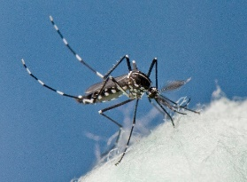Involving your whole neighborhood in mosquito prevention and clean-up events is also important. Keeping your yard free of mosquito breeding areas won't eliminate these annoying bloodsuckers if your neighbors aren't doing their part.

Resource: University of Florida

**Table of Contents**

**ZIKA** 1

**Planting Calendar** 2

**October** 2

**November** 2

**December** 2

**Time for Strawberries!** 3

**Insecticidal Soap** 4

**Horticultural Services** 5

**Weed-B-Here?** 6

**Gardening and Landscaping Resources** 7

**COMMUNITY CALENDAR** 8

COMMERCIAL 8

**Bayer to acquire Monsanto for $66 billion**

**Effective 2017**

# **Planting Calendar**

<http://solutionsforyourlife.ufl.edu/lawn_and_garden/calendar/pdfs/October_Central.pdf>

## **October**

**Strawberry month! See page 3**:

Prepare beds and set strawberry plants this month.

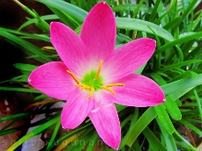Petunia, alyssum and pansy are good annual plantings. Plant or move bulbs in the garden for spring blooming. Agapanthus, **rain lily**, amaryllis, crinum, and daylily are just a few good choices for blooms next spring.

**Herbs and veggies:** Some herbs to try are parsley, cilantro, chives, garlic, thyme and sage. Beets, Brussel sprouts, cauliflower, lettuce cabbage carrot and onion can go in now.

**Lawn weeds:** The best time to control winter weeds in lawns is before they appear. Apply pre-emergent herbicides when nighttime temps are 55°F-60°F for 4-5 days to be effective.

**Winter landscapes: Evergreen hollies** and their bright berries add color to the landscape when other plants have died back for the winter. Water well when planting and mulch to minimize weeds.

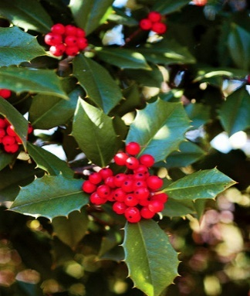

<http://solutionsforyourlife.ufl.edu/lawn_and_garden/calendar/pdfs/November_Central.pdf>

**November**

**Bedding Plants:** Create a display of fall colors with cool season plants. Some to try are ornamental cabbage, pansy, viola, snapdragon, dianthus, cape daisy, and alyssum.

**Irrigation:** Turn off systems and water only if needed.

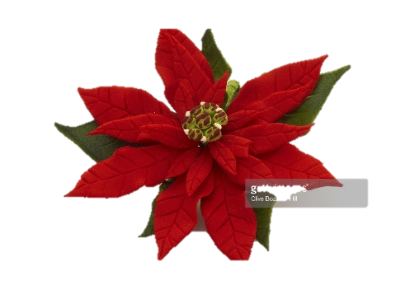**Poinsettias:** Watch for hornworms on poinsettias planted in the landscape. This pest can quickly defoliate the plant; handpick or treat only the area infested.

**Fertilize** Bermudagrass and Zoysia lawns:Choose a fertilizer (not a weed & feed) with little or no phosphorus and controlled-release nitrogen.

You can prepare your gardens with a pot-in-pot system by sinking empty nursery pots into the ground then placing same size nursery potted plants into them. Start with pansies, cabbage, chrysanthemums, and kale.

Switch out plants each season.

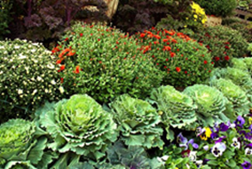<http://solutionsforyourlife.ufl.edu/lawn_and_garden/calendar/pdfs/December_Central.pdf>

## **December**

**Bedding Plants:** To add color to the winter garden, plant masses of petunia, pansy, and snapdragon.

**Bulbs:** Amaryllis is a popular plant for the holiday season. Force it to bloom now or plant outdoors for spring blooms.

**Herbs:** Plant herbs that thrive in cool weather. Some to try are parsley, thyme, sage, dill, fennel, and cilantro.

**Poinsettias:** One of the most popular holiday plants is poinsettia. Enjoy it indoors now, protect it from cold until spring, and then plant in the garden for re-blooming next year.

**Houseplants:** Inspect regularly for pests on indoor plants. Keep in mind that plant specific temperature, light, and humidity are key to ensuring that indoor plants thrive.

**Pests:** While cooler weather generally means fewer pests, some populations actually increase at this time of year. Continue monitoring and treat as needed.

**Cold protection**: Prepare now to protect tender plants should cold weather threaten.

**Soil Test:** A yearly soil test will keep your plants happy and growing. pH tests are done at the Extension Service. **See page** 5

***Return to Table of Contents***

## **Time for Strawberries!**

This is a brief summary of the in-depth information at the University of Florida website:

***Growing Strawberries in the***

***Florida Home Garden***

Craig K. Chandler, Natalia A. Peres, Vance M. Whitaker, Hugh A. Smith, and Sydney Park Brown

[**http://edis.ifas.ufl.edu/pdffiles/HS/HS40300.pdf**](http://edis.ifas.ufl.edu/pdffiles/HS/HS40300.pdf)

Late September to early November marks the beginning of strawberry season. Homegrown berries are truly sweet and juicy because you don’t pick them until they are actually ripe. Strawberries do not ripen after picking.

#### **Try Container Gardens**

There is no reason in the world why you should spend your winter months stooped over an in-ground strawberry patch. Strawberries will happily grow in hanging planters, decorative urns and home built strawberry tray systems.

**Pests:** There are advantages to keeping the plants off the ground. Not that some persistent slugs won’t find their way up but there would be fewer. Organic mulches such as straw or wood chips foster slugs so use the black plastic with planting slits instead. Iron phosphate, sand or diatomaceous earth can help kill slugs.

The birds that seem so interested in the berries are often more interested in the bugs and slugs around the fruit. They can be your partner in a successful season.

#### **Basic Technical Stuff**

Temperatures between 50 and 80°F and day lengths 14 hours or less are required for the development of flowers and fruit on most strawberry varieties.

Single-crown (stem) strawberry plants are the type planted in Florida during the fall, from late September to early November. Flowering and fruit production generally begins in November and continues into April or May. Fruit production over this period is not constant, but occurs in two or three cycles; freezing weather will interrupt these cycles.

The highest quality fruit comes from the younger plants having no more than four or five branch crowns. As your plants get less productive and produce runners, remove the old and replace with the new babies.

#### **Varieties**

Currently, two varieties produce attractive, flavorful berries suitable for eating fresh or for freezing. ‘Festival’ and ‘Sweet Charlie’ produce more fruit during the early part of the season and have been the most productive varieties in Central Florida.

‘Radiance’ is a newer variety that produces more fruits earlier and throughout the season in Central Florida. However, the plant is not as strong as the other varieties listed and may require careful handling and attention during establishment.

These varieties are capable of producing 1 to 2 pints of fruit per plant over the season.

#### **Planting Methods**

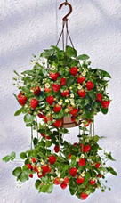There are so many ways to grow strawberries! Remember to include adequate and quick drainage. Strawberries don’t like to keep their feet wet.

In ground is the traditional way to plant strawberries. Here are some not-so-traditional ways homeowners have invented:

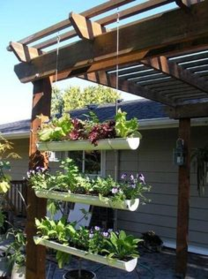Rain gutter racks hung from roof edge. This can be interspersed with herbs.

These have four planting “shelves” for easy maintenance. Tipping each gutter provides good drainage. Weeding is easier with this method.

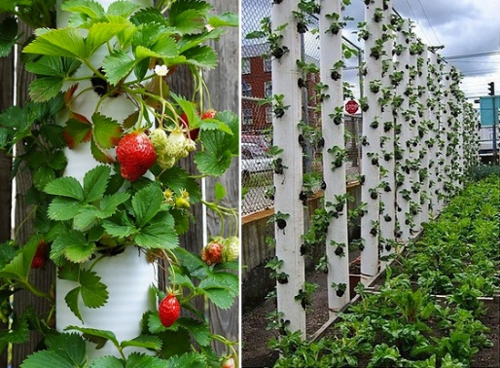Vertical PVC Strawberry Planter. Using PVC pipes with holes for the plants is space saving and quite productive. Water from the top.

Whether you plant just one plant or go for larger production, you surely will enjoy the marvelous difference between store-bought and home grown.

***Return to Table of Contents***

## [Image result for leaf](https://www.google.com/url?sa=i&rct=j&q=&esrc=s&source=images&cd=&cad=rja&uact=8&ved=0ahUKEwjsjtmahpjPAhUE7iYKHSMXBHgQjRwIBw&url=https://a2ua.com/leaf.html&bvm=bv.133178914,d.amc&psig=AFQjCNF9SUTT61wPHenNG1WJ8_3mcs8N-Q&ust=1474258259990929)**Insecticidal Soap**

**CLEAN UP PESTS WITH SOAP**

****Insecticidal soaps offer a safe but effective management of some of our most troublesome landscape pests. Still, understand that this is not the "Silver bullet" for all situations, and as with all insecticides, not without risks.

**Insecticidal Soaps are effective for SOFT BODIED PESTS.** This includes aphids, thrips, scales, spider mites and immature white flies and leafhoppers.

This soap is also effective on the black, papery scum that appears on the surface of plant leaves and stems. This is sooty mold, which grows on the waste materials secreted by these pests.

Insecticidal soaps kill susceptible insects by washing away the protective waxy coating of the insect. Soap enters the pest’s respiratory system and causes internal damage by breaking down cell membranes. It also affects the growth of immature insects. Insecticidal soaps are generally about 40-50% effective against these pests.

Insecticidal soap rarely effects the hard-bodied beneficial insects such as ladybug beetles and predaceous wasps. **This is part of the reason why soaps are environmentally friendly.**

* Soap has no *residual* value as an insecticide - it is only effective against insects that come into contact with the **wet spray**. Once the spray has dried, a moving insect will not be harmed by walking over the residue.

**Coverage, therefore, is extremely important.** For example, spraying the upper leaf surface will leave whiteflies alive and healthy, since they usually feed under the leaves. The insects must come into direct contact with the spray droplets for the material to be effective. Insects that cannot be completely wetted, such as aphids within curled leaves, will not be controlled. The immature stages of some of these insects move little or not at all, and will be killed only if the wet material touches them.

**MAKE YOUR OWN**

**If you make your own, do not use soaps that contain a degreaser. And do not use automatic dishwashing soap or detergent. These will cause damage or even kill your plants.**

Give serious thought to purchasing commercially made preparations that are prepared under strict inspection and provide a pesticide label for your safety. Not only is it a good idea to read and follow all label directions - it’s the law. Some commercial insecticidal soap products contain additional botanical insecticides such as citrus oils or pyrethrins. Read the label.

**To make your own**, UF entomologist Dr. Short suggests that 2 Tablespoons of mild (degreaser free) dishwashing liquid per gallon of water are appropriate amounts of soap to use against mites, aphids, mealybugs, whiteflies, soft scales and thrips on many ornamentals. This recipe will produce slightly less than a 1% solution.

* **Measure carefully: Higher concentrations of soap may not only dissolve the wax-like shell of an insect, but may also do the same to the waxy surface of plant leaves.**
* Use the purest water possible for insecticidal soaps**.** Hard water reduces the effectiveness of insecticidal soaps. Calcium, magnesium and iron found in hard water turn into soap scum, making your mix useless against the insects**.**

Watch for phytotoxicity, an adverse plant reaction or injury from the soap treatment. When in doubt, test first.

.

Avoid treating sensitive plants. Among the ornamental plants reported to be sensitive to soap sprays are gardenia, maidenhair fern, and crown of thorns, lantana, nasturtiums, and Easter lilies (during bud formation).

* The best time to apply is in the early morning. The material works only while wet and the slower drying conditions in early morning favor better control.
* Apply when the temperature is below 90 degrees F and not in full sun.
* Don't treat plants under drought or other kinds of stress.
* Hairy leaved plants may hold spray droplets. These droplets can act as magnifying lenses and cause some burning.
* Young foliage may very sensitive. Wait for new growth to harden off before treating.
* Do not spray fruit trees in bloom. 

And that is the beginning. You will learn as you go: be sure to TEST in a small area if you are not sure of sensitivity of a plant.

Reference: View the entire article by Daniel F. Culbert, University of Florida Extension Agent and Dr. Short

[**http://okeechobee.ifas.ufl.edu/News%20columns/Clean%20Up%20Pests.htm**](http://okeechobee.ifas.ufl.edu/News%20columns/Clean%20Up%20Pests.htm)

***Return to Table of Contents***

# **Horticultural Services**

**Working for you and with you**

**Soil Testing**

The University of Florida recommends that you test your soil every season in order to maintain optimal results.

<http://edis.ifas.ufl.edu/ss494>

The Master Gardener Help Desk will test the pH of your soil in the office: $2.00 per sample. Call for instructions or request a copy of the brochure that fully explains the proper way to collect samples:407-665-5550.

For a more comprehensive soil test, the Help Desk personnel will provide you with the requirements and cost to send your sample(s) to the University of Florida. Weekdays: 9 am – 12 pm AND 1 pm – 4 pm 407-665-5550

**Master Gardener Help Desk**

An experienced Master Gardener will help solve garden problems through discussion, knowledge and computer research.

Other services include, but are not limited to:

* Plant Problems: bring us a sample of your plant, including the flower and the pest.
* Plant identification and care
* Irrigation questions and solutions
* Bug and treatment identification
* The Help Desk has a wide range of FREE printed copies of University of Florida IFAS publications.
* **PLEASE NOTE**

***At this time, we are not equipped to send or receive pictures nor perform house calls.***

**Classes**

The Extension Service continually offers specific classes relevant to the season and needs of the community.

Class offerings include Vegetable Gardening; Rain Barrels; Hydroponics; butterfly gardening and much more!

**School Gardening**

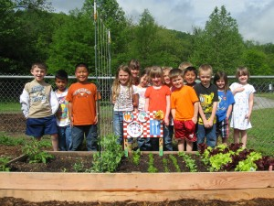The Master Gardeners have launched an extensive on-site interactive school gardening program. Currently, the gardeners are concentrating working with the students at Goldsboro Elementary School. Other schools planned for 2016. For more information:

**Master Gardener Expo**

Held in the spring of each year. Includes local horticulture vendors and craftsmen; food; popular gardening speakers; demonstrations; children’s section, etc. Great fun!

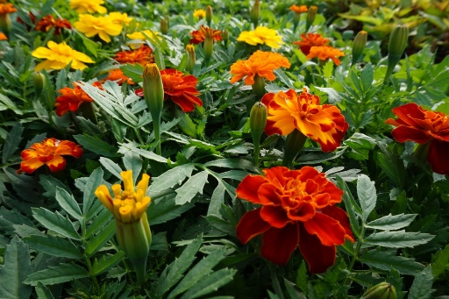**Plant Sale**

This is an event that residents look forward to each year! It offers a huge array of beautiful locally grown plants and generous donations from local nurseries. Traditionally held at the Seminole County Extension Service Complex.

**Seminole County Garden Walk**

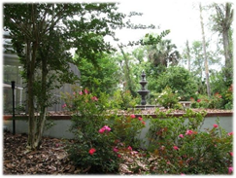A neat opportunity to visit extraordinary private gardens throughout the county. Residents open their gardens to the public for a day. A printed guidebook includes a map of the location of each garden. You choose which gardens you want to see. A Master Gardener stationed at each garden will answer any questions you may have.

**Theme & Demonstration Gardens**

* **Micro Irrigation**: The Florida Friendly Landscaping Florida Native Plant garden, Butterfly garden and the vegetable garden at the Seminole County Extension.
* **Butterfly/Pollinator Garden** at the Seminole County Extension complex: This garden includes a small pond and ground bee houses.
* **Florida WaterWise Garden**

Located at the Extension Service complex.

**“Ask a Master Gardener” booth at special events**

You will often find this service at local municipal events such as May Day; Arbor Day; Plant Sales; Expos/community celebrations, and garden related retail locations.

If your community or business would like to have an “Ask a Master Gardener” booth at your event, contact the extension service: 407-665-5550

***Return to Table of Contents***

**Taryn Sudol, FFL Agent**

**Seminole County Cooperative Extension**

# **Weed-B-Here?**

Weeds have been quick to pop up in my garden, but I have been less quick to grab my gloves and hat. When I visit the garden, I cringe and note all the weeds that have to go. A little later, as I walk around a lake, I pleasantly spot some of the same plants that have established under the lawn mower’s radar.

We must remember that a weed is simply a plant out of place. Do we have a place for some these typically “weedy” plants?

If your answer is NO, then I recommend mulch, timely pre-emergent herbicide, or a good pair of gloves and constant diligence.

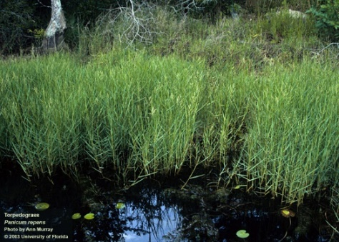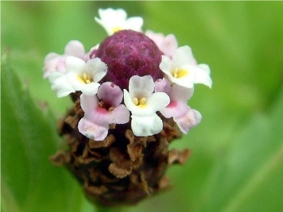If your answer is “maybe?” let’s explore some “weed” benefits. First, we have to identify the plants we have in mind. If the Florida Exotic Pest and Plant Council (FLEPPC) has categorized a plant as invasive, these plants are harming the natural environment, economy and/or human health. Remove these plants: they include:

**torpedograss**,

cogon grass,

and air potato,

to name a few. Meanwhile there exists a host of native plants that wildlife enjoy or even make good editions to our salads.

The host plant for the white peacock butterfly is **frogfruit**, a low growing, and purplish forb with small white flowers. If you want more white peacock butterflies fluttering across the ground, leave the **frogfruit.**

You can mow the way you normally do (though think about raising the mowing to four or five inches) so you have a nice, flat expanse but your area will be more biodiverse. If you’re happy as long as the yard is green and trim, frogfruit, pusley, Virginia buttonweed or purslane can unobtrusively cohabitate your yard, drought tolerant and fertilizer-free!

Are you ready to spice up your salads? Add some dollar weed, peppergrass or Spanish needles! Dollar weed tastes like parsley. Add it to dips or salad. ! If you know your weeds haven’t been treated with dangerous chemicals, start harvesting!

Many different native “weeds” are edible or ethnobotanical. UF IFAS Extension in St. Lucie created a longer list at <http://stlucie.ifas.ufl.edu/pdfs/master_gardener/2014/Edible%20Weeds.pdf>

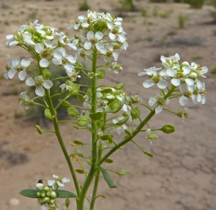**Peppergrass** is peppery, and the roots can be used like horseradish.

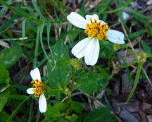**Spanish needles** are more nutritional than spinach!

Depending on your yard, there may be back sections or corners that don’t get much use and you don’t care to mow them. Consider letting those spaces grow freely and see what comes up from the soil or with the help of birds. Wildlife will find much more interest in this vegetation than turf grass. Your weed may be a pollinator’s treasure.

*Would a rose by any other name be just as sweet? Could a weed by any other name be more charming? Think what weeds are right for you and deserve to stick around –otherwise, get pulling!* ***Return to Table of Contents***

# **Gardening and Landscaping Resources**

**Seminole County Extension**

**Residential Horticulture**

250 W. County Home Road

Sanford, Fl 32773

407-665-5550

[**www.seminolecountfl.gov/extension**](http://www.seminolecountfl.gov/extension)**services**

*Located at the intersection of Hwy. 17-92*

*and County Home Road*

**SEMINOLE GREENTHUMB**

*Free Quarterly Newsletter*

**Contributors:**

Taryn Sudol

Mary Allen

Kelly DiCristina

**Useful websites**

University of Florida IFAS-Extension

[**http://solutionsforyourlife.com**](http://solutionsforyourlife.com)

[**http://edis.ifas.ufl.edu**](http://edis.ifas.ufl.edu)

[**http://hort.ifas.ufl.edu**](http://hort.ifas.ufl.edu)

[**http://fyn.ifas.ufl.com**](http://fyn.ifas.ufl.com)

**To view Monthly Planting Calendar**:

[**Florida Gardening Calendar - UF/IFAS Extension: Solutions for Your Life**](http://solutionsforyourlife.ufl.edu/lawn_and_garden/calendar/) **Vegetable Gardening:**

[**http://edis.ifas.ufl.edu/pdffiles/VH/VH02100.pdf**](http://edis.ifas.ufl.edu/pdffiles/VH/VH02100.pdf)

*The Institute of Food and Agricultural Sciences is an Equal Employment Opportunity-Affirmative Action Employer authorized to provide research, educational information and other services only to individuals and institutions that function without regard to race, color, sex, age, handicap or national origin.*

*COOPERATIVE EXTENSION WORK IN AGRICULTURE, HOME ECONOMICS, STATE OF FLORIDA, IFAS, UNIVERSITY OF FLORIDA, U.S. DEPARTMENT OF AGRICULTURE AND BOARDS OF COUNTY COMMISSIONERS COOPERATING***Watering Schedule**

**Restrictions and Tips**

**March 13, 2016**

**through November 5, 2016**

THESE RESTRICTIONS ARE MANDATORY IN SEMINOLE COUNTY AND INCLUDE THOSE ON PRIVATE WELLS OR LAKES, ETC. THESE RESTRICTIONS apply to everyone in Seminole County who uses water for lawn and landscape irrigation, regardless of whether the water comes from a private well, surface water or a water supply utility.

**NO WATERING BETWEEN 10 a.m. TO 4 p.m. ANY DAY**

Residential customers with odd-street addresses water on Wednesday and Saturday.

Residential customers with even street addresses water on Thursday and Sunday.

Non-Residential customers (business, schools, churches, recreational facilities, etc.) water on Tuesday and Friday.

Reclaimed water customers may water two times a week according to your address year round (Follow the odd, even schedule for Daylight Saving Time) These restrictions are mandatory in Seminole County and include those on private wells or lakes, etc.

**NO WATERING BETWEEN 10 A.M. TO 4 P.M. ANY DAY**

**THESE RESTRICTIONS ARE MANDATORY IN SEMINOLE COUNTY AND INCLUDE THOSE ON PRIVATE**

**WELLS OR LAKES, ETC.**

If you see Watering Violations, report them!

* Watering is allowed at any time with a hand-held hose provided it is fitted with an automatic shutoff nozzle. This applies to all sources of irrigation water.
* **Personal vehicle washing** allowed only if you use a hand-held hose fitted with an automatic shutoff nozzle.
* Newly planted landscaping may be irrigated any day between the hours of 4:00 PM and 10:00 AM for the first 30 days following installation.

**For the WINTER restrictions go to:**

<http://www.seminolecountyfl.gov/departments-services/environmental-services/water-conservation/watering-restrictions.stml>

***Return to Table of Contents***

**Community Calendar**

Classes, Community Events and CEU courses

<http://www.seminolecountyfl.gov/departments-services/leisure-services/extension-services/>

|  |
| --- |
| COMMERCIAL |
| *The Seminole County Commercial Horticulture Agriculture program provides education and training based on the latest research from the University of Florida.*  CEU classes  <http://www.seminolecountyfl.gov/departments-services/leisure-services/extension-services/commercial-resources/>  <http://sfyl.ifas.ufl.edu/education/index.shtml> |
| Training & CEUs  Many training programs, certification opportunities, and continuing education units (CEUs) are available through Extension, often in conjunction with FDACS and the USDA. Get information about the courses and materials offered for professionals in Florida's agriculture, building construction, childcare, nutrition, horticulture, and pest control industries.  Agricultural Production  Building Construction & Development  Child Care  Food & Nutrition  Horticultural Production  Pest Control & Pesticide Licensing  Short Courses  More online interactive training modules and videos are available (for free or for sale) through Extension Continuing Education Solutions.   * For information about training programs available for gardeners, naturalists, and beekeepers, see Nonprofessional Programs. <http://solutionsforyourlife.ufl.edu/education/nonprofessional.shtml> * For personal assistance or information about the Extension services and courses offered in your area, contact your county Extension office. 407-665-5550 * For information on college-credit courses, certificates and degrees at either the undergraduate or graduate level offered by University of Florida see Distance Learning: <http://www.distance.ufl.edu/> |

***Return to Table of Contents***