Contents

What’s Cookin’ 2

UF/IFAS and Chef David Bearl team up with Bok Tower Gardens 2

Goldsboro Elementary students learn gardening for fresh produce 2

Central Florida Planting Calendar 3

Local Food Market 4

*Local* is a relative term 4

Florida Yards & Neighborhoods Program 5

Pace to Plant 5

HORTICULTURAL SERVICES 6

COMMUNITY CALENDAR 8

COMMERCIAL 8

Should-da – Could-da - Would-da 9

Hurricane Prep 9

# **Topic Links**

**ZIKA VIRUS**

[**http://mosquito.ifas.ufl.edu/Documents/USDA_Zika_Pest_Alert.pdf**](http://mosquito.ifas.ufl.edu/Documents/USDA_Zika_Pest_Alert.pdf)

[**http://stlucie.ifas.ufl.edu/pdfs/natural_resources/2016/Zika-February2016.pdf**](http://stlucie.ifas.ufl.edu/pdfs/natural_resources/2016/Zika-February2016.pdf)

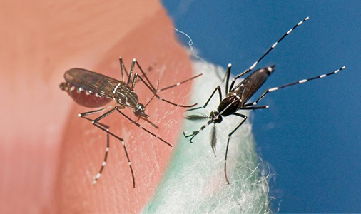

# **What’s Cookin’**

## **UF/IFAS and Chef David Bearl team up with Bok Tower Gardens**

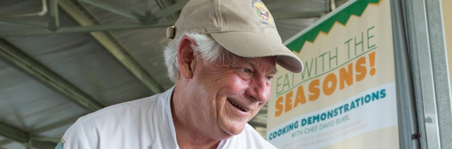

Forty Florida middle school students learned to cook fresh, healthy meals with a professional chef, thanks to the partnership between University of Florida Institute of Food and Agricultural Sciences Extension and Bok Tower Gardens. The cooking demonstration held May 20, 2016, celebrated the recent opening of the new **Outdoor Kitchen and Edible Garden at Bok Tower Gardens.**

Tricia Martin, director of education at Bok Tower Gardens, worked with said Chef David Bearl to design the kitchen with a chef’s needs in mind. The kitchen features state-of-the-art appliances, a wood-fired brick oven, granite countertops and seating for 40 people. The Outdoor Kitchen and Edible Garden will inspire meals prepared with the seasonal fruits and vegetables grown onsite.

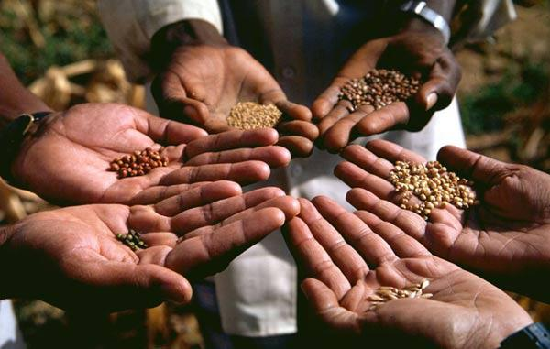Local high school students who are part of their school’s culinary program will work as Bearl’s sous chefs and act as mentors for the middle schoolers.

In addition to teaching kids about nutrition and food sources, Martin sees the cooking demonstration as chance to demonstrate career opportunities in the culinary arts.

This event will further strengthen the partnership between UF/IFAS and Bok Tower Gardens, and help serve the mission of both institutions to encourage healthy living and appreciation of natural resources, Martin said.

The Outdoor Kitchen and Edible Garden “represents the goals of the partnership to provide experiential education that’s going to enrich people’s lives,” Martin said.

“Bok Tower is a teaching institution,” said Bearl, “and these kinds of partnerships only help spread the word about UF/IFAS.” Bearl trains program assistants in the UF/IFAS Family Nutrition Program and is the UF/IFAS Farm to School chef and is certified by the American Culinary Federation.

## **Goldsboro Elementary students learn gardening for fresh produce**

Seminole County is one of only six districts in the nation to participate in the Activate for Kids program, and about half of the schools in the district have started some sort of wellness initiative. Since the program’s launch, about half of the middle schools and two high schools have also joined.

The vegetable gardening at **Goldsboro Elementary in Sanford** has been an ongoing successful project for many seasons and has incorporated the cooking element on several occasions, using the school kitchen. Not as fancy as Bok Towers but surely as effective. Which goes to show you: it doesn’t matter where you cook your home growns - just who has the privilege of eating them.

The gardens, which are part of a program called **Seeds of Change**, teach students the importance of healthy eating habits and allows science teachers to show students the process of growing food. **Seminole County Master Gardeners** are the teachers of designing, planting and maintenance of the raised bed vegetable gardens**.**

Sources:

* David Bearl, david.bearl@ufl.edu
* <http://blogs.ifas.ufl.edu/global/category/sfyl-hot-topic/>
* Rachel Delinski, Sanford Herald Editor, May 21, 2012
* UF/IFAS (Bearl) Photo by Tyler Jones

***Return to Table of Contents***

# **Central Florida Planting Calendar**

**July, August, September**

***Be sure to review the hurricane prep guidelines:***

***Should-da - Could-da - Would-da***

**SOLARIZE** annual gardens. Use summer heat as a tool in preparing the vegetable or annuals garden for fall planting. It takes 4-6 weeks to kill weeds, disease and nematodes, so start now - it sure beats fighting the pests later.

**July**

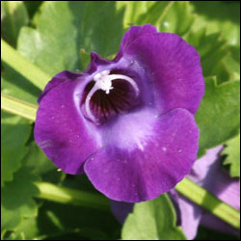

**Summer annuals:** celosia, coleus, torenia and ornamental pepper.

**Bulbs:** Butterfly lily *Moraea* (African lily), and gladiolus

**Azaleas:** Prune no later than mid-July to protect developing buds for next spring’s bloom.

**Pests on Ornamental Plants:** Small white dots on the leaves of azaleas and other ornamental plants may indicate lacebugs at work. Spray forcefully with water to help control this pest.

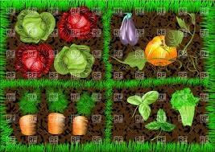**August**

**Herbs:** Herbs that can be planted from plants (not seeds) include bay laurel, ginger, Mexican tarragon, and rosemary.

**Vegetables:** This month starts the fall planting season. Plant cool season crops now, including a final crop of warm-season vegetables such as pepper.

You can plant butterfly lily, walking iris, and spider lily any time of the year, even late summer.

**Poinsettias:** Pinch back Poinsettias and Mums before the end of the month to allow time for buds to form for winter bloom.

**September**

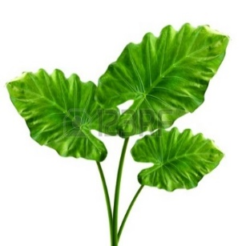

Add color, texture and pattern to the garden with the many varieties of Elephant’s Ear (Alocasia) now available for fall planting.

* Start the fall planting season now. Plant cool season vegetable crops such as celery, cabbage, lettuce, and collards.
* Start tomatoes.
* Divide and replant perennials and bulbs that have grown too large or need rejuvenation. Add organic matter to new planting areas and monitor water needs during establishment.
* 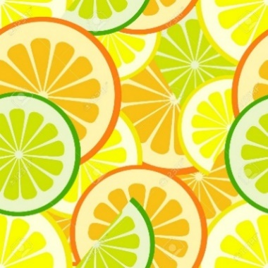**Citrus:** Fertilize citrus with a balanced fertilizer either this month or in October. If the weather has been rainy, do not use soluble nitrogen, as rains will leach it from the soil too quickly.
* **Vegetable gardens**: If not done in August, prepare the fall vegetable garden.

Using transplants from your local garden center will get the garden off to a fast start, but seeds provide a wider variety from which to choose.

***Return to Table of Contents***

# **Local Food Market**

## ***Local* is a relative term**

Consumers have become more interested in reconnecting with their food and the farmers who produce it. This has sparked the growth of the local food movement into a multi-billion dollar industry in Florida.

However, there is no official definition of local food in the way that there is for USDA organic food, for example. As a result, “local” has become a relative term.

A consumer will say that a tomato grown in their county is more local than one grown in another part of the state. However, a tomato grown anywhere in Florida is more local than one grown in Mexico.

Professor Joy Rumble at UF/IFAS knew her research findings on consumer opinions could help producers better reach their customers. She believed that in-person training was the best way to deliver these insights and created; “Promoting Specialty Crops as Local” that teaches specialty crop farmers why people choose local foods and how farmers can use this information to market their Florida-grown products.

The curriculum contains six modules than can be taught individually or as a whole. When participants finish the curriculum, they walk away with a complete promotional plan for their specialty crops.

Specialty crops, which include fruits, vegetables, tree nuts and landscape plants, are a 5.4 billion dollar industry in Florida and competing with international markets can be challenging. Florida farmers can counter these pressures by capitalizing on consumers’ positive feelings toward local foods and by telling a compelling story about their farms.

Rumble hopes the impact of the curriculum will be that crop producers across the state will be able to better promote their farms and products through the communication strategies suggested in the curriculum. “[This] will benefit Florida agriculture as a whole and serve to connect Florida consumers with the industry.”

Another goal of the curriculum is to help producers better define what they mean by local food. “As an industry, we have to be really careful with the term. The more explicit we can be the better. You need to be transparent about your products,” Rumble says.

Extension agents can use this curriculum, funded by the Florida Department of Agriculture and Consumer Services Florida Specialty Crop Block Grant Program, to help producers make informed choices about promoting their farms and specialty crops. The six modules are available individually or together in a class environment and includes a PowerPoint, suggested script, activities, resources, and an evaluation.

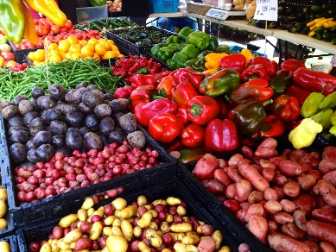The curriculum, funded by the Florida Department of Agriculture and Consumer Service’s Florida Specialty Crop Block Grant program, and was a collaboration of the UF/IFAS Center for Public Issues Education with the Florida Specialty Crop Foundation.

Creator of course: Joy Rumble, Professor of Agricultural Education and Communication at UF/IFAS

<http://blogs.ifas.ufl.edu/global/2016/06/02/ufifas-helps-local-farmers-break-local-food-movement/>

For a digital version of the curriculum, go to <http://www.piecenter.com/training/local/>

Agricultural producers interested in taking the course should contact their local UF/IFAS Extension office.

<http://www.piecenter.com/training/local/>

***Return to Table of Contents***

# **Florida Yards & Neighborhoods Program**

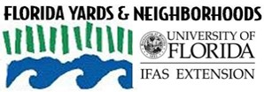

**Taryn Sudol**

FYN Extension Agent

UF-IFAS Extension at Seminole County

407-665-5575

tsudol@seminolecountyfl.gov

www.seminolecountyfl.gov/fyn

|  |  |
| --- | --- |
| 1. **Right Plant, Right Place** | **6. Manage Yard Pests Responsibly** |
| 1. **Water Efficiently** | **7. Recycle** |
| 1. **Fertilize Appropriately** | **8. Reduce Stormwater Runoff** |
| 1. **Mulch** | **9. Protect the Waterfront** |
| 1. **Attract Wildlife** | **10. Honor native plants and trees** |

­

## **Pace to Plant**

The right plant in the right place (the tenant of Florida-Friendly Landscaping) is the best defense against pest problems. A plant in a stressed environment will be more susceptible to pest infestations. Unfortunately, trees in urban environments face multiple stresses that increase their vulnerability to pests. Dr. Adam Dale, a recent addition to the University of Florida’s Entomology Department, has already linked ***impervious surface cover*** to a red maple’s condition and its scale infestations.

Red maple is a beautiful and adaptable Florida native tree. Its range of soil conditions and bright fall foliage makes it a commonly planted landscape tree. The most significant pest to red maples is gloomy scale, a native armored scale, which feeds on fluids within the trunk and branches of trees. Small and armored, the scale usually withstands typical pest management such as herbicide treatments.

While gloomy scale would never be a welcomed guest on a red maple, an urban red maple faces a tougher battle. Urban environments have more impervious surfaces –asphalt on sidewalks, roads, parking lots where water can’t seep through. More impervious surfaces mean an increase in air temperature, reduces soil moisture and oxygen, and increased soil compaction. This makes the trees hotter and more drought stressed. The scale meanwhile enjoys the heat and the stressed tree; in fact, female scales produce up to 3 times as many offspring in hotter conditions. . A study in Raleigh, NC found that gloomy scale are up to 200 times more abundant on red maple trees in the hottest urban sites than nearby sites just 2-3o C cooler.

**The relationship between impervious surface and gloomy scale on red maples is so strongly connected that Dr. Dale developed a “Pace to Plant” technique to determine if the site is suitable enough for red maple. It depends on the percentage of impervious surface within 25 meters of the red maple tree.**

How do you know the percentage of impervious surface? You walk. You start at the tree, orient yourself toward the nearest sidewalk and/or roadway and take 25 steps. Count which steps touch vegetation and which steps are on pavement**.** Angle yourself 90 degrees from where you started and repeat. Do this twice more. In total, you have taken 100 steps. The number of steps you’ve taken on impervious surface is the percentage you need. Consult the table to see whether your red maple tree is in good, fair or poor condition.

**Dr. Dale is hoping to expand this research so you can use the “Pace to Plant” technique on different tree species with different thresholds of impervious surface. Our urban forests are a powerful and beneficial presence in our community but only if the right plant is in the right place**.

|  |  |
| --- | --- |
| **% impervious surface** | **Red maple condition** |
| 0-32% | Good |
| 32-62% | Fair |
| 62-100% | Poor |

***Return to Table of Contents***

# HORTICULTURAL SERVICES

**Working for you and with you**

**Soil Testing**

The University of Florida recommends that you test your soil every season in order to maintain optimal results.

<http://edis.ifas.ufl.edu/ss494>

The Master Gardener Help Desk will test the pH of your soil in the office: $2.00 per sample.

Call for instructions or request a copy of the brochure that fully explains the proper way to collect samples: 407-665-5550.

For a more comprehensive soil test, the Help Desk personnel will provide you with the requirements and cost to send your sample(s) to the University of Florida.

Weekdays: 9 am – 12 pm AND 1 pm – 4 pm

407-665-5550

**Master Gardener Help Desk**

An experienced Master Gardener will help solve garden problems through discussion, knowledge and computer research.

Other services include, but are not limited to:

* Plant Problems: bring us a sample of your plant, including the flower and the pest.
* Plant identification and care
* Irrigation questions and solutions
* Bug and treatment identification
* The Help Desk has a wide range of FREE printed copies of University of Florida IFAS publications. Come on in and browse the collection.

***PLEASE NOTE:***

***At this time, we are not equipped to send or receive pictures nor perform house calls.***

**Classes**

The Extension Service continually offers specific classes relevant to the season and needs of the community. Class offerings include:

|  |  |
| --- | --- |
| * Vegetable Gardening * Micro Irrigation * Rain Barrels * Hydroponics | * Organic Gardening * Container Gardening * Butterfly Gardening * Vermiculture (Worm Humus) Farming |

**School Gardening**

The Master Gardeners have launched an extensive on-site interactive school gardening program. Currently, the gardeners are concentrating working with the students at Goldsboro Elementary School. Other schools planned for 2016. For more information: G. Milch: 407-665-5558.

**Master Gardener Expo**

Held in the spring of each year. Includes local horticulture vendors and craftsmen; food; popular gardening speakers; demonstrations; children’s section, etc. Great fun!

See pictures from March 5, 2016 click here: Expo – the exciting results

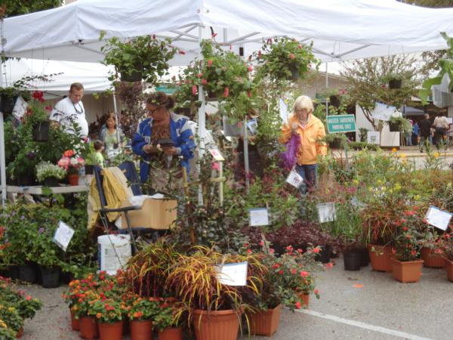**Plant Sale**

This is an event that residents look forward to each year! This event offers beautiful locally grown plants and generous donations from local nurseries. Traditionally held at the Seminole County Extension Service Complex.

**Seminole County Garden Walk**

This is a neat opportunity to visit extraordinary private gardens throughout the county. Residents open their gardens to the public for a day. A printed guidebook includes a map of the location of each garden. You choose which gardens you want to see. A Master Gardener stationed at each garden will answer any questions you may have.

**Theme & Demonstration Gardens**

* **Micro Irrigation**: The Florida Friendly Landscaping Florida Native Plant garden, Butterfly garden and the vegetable garden at the Seminole County Extension.
* **Butterfly Garden** at the Seminole County Extension complex: This garden includes a small pond and ground bee houses.

**“Ask a Master Gardener” booth at special events**

You will often find this service at local municipal events such as May Day; Arbor Day; Plant Sales; Expos/community celebrations, etc.

If your community or business would like to have an “Ask a Master Gardener” booth at your event, contact the extension.

***Return to Table of Contents***

**Your community resource for gardening and landscaping information**

###### **Seminole County Extension**

**Residential Horticulture**

250 W. County Home Road

Sanford, Fl 32773

407-665-5550

[www.seminolecountfl.gov/extension](http://www.seminolecountfl.gov/extension)services

*Located at the intersection of Hwy. 17-92*

*and County Home Road*

**SEMINOLE GREENTHUMB**

*Free Quarterly Newsletter*

###### Contributors:

Taryn Sudol

Mary Allen

Kelly DiCristina

**Useful websites**

University of Florida IFAS-Extension

<http://solutionsforyourlife.com>

<http://edis.ifas.ufl.edu>

<http://hort.ifas.ufl.edu>

<http://fyn.ifas.ufl.com>

**To view Monthly Planting Calendar**:

[Florida Gardening Calendar - UF/IFAS Extension: Solutions for Your Life](http://solutionsforyourlife.ufl.edu/lawn_and_garden/calendar/)

**Vegetable Gardening:**

<http://edis.ifas.ufl.edu/pdffiles/VH/VH02100.pdf>



The Institute of Food and Agricultural Sciences is an Equal Employment Opportunity-Affirmative Action Employer authorized to provide research, educational information and other services only to individuals and institutions that function without regard to race, color, sex, age, handicap or national origin.

COOPERATIVE EXTENSION WORK IN AGRICULTURE, HOME ECONOMICS, STATE OF FLORIDA, IFAS, UNIVERSITY OF FLORIDA, U.S. DEPARTMENT OF AGRICULTURE AND BOARDS OF COUNTY COMMISSIONERS COOPERATING. **WATERING SCHEDULE**

**Restrictions and Tips**

**EFFECTIVE --- March 13, 2016 through November 5, 2016.** THESE RESTRICTIONS ARE MANDATORY IN SEMINOLE COUNTY AND INCLUDE THOSE ON PRIVATE WELLS OR LAKES, ETC. THESE RESTRICTIONS apply to everyone in Seminole County who uses water for lawn and landscape irrigation, regardless of whether the water comes from a private well, surface water or a water supply utility.

**NO WATERING BETWEEN 10 a.m. TO 4 p.m. ANY DAY**

Residential customers with odd-street addresses water on Wednesday and Saturday.

Residential customers with even street addresses water on Thursday and Sunday.

Non-Residential customers (business, schools, churches, recreational facilities, etc.) water on Tuesday and Friday.

Reclaimed water customers may water two times a week according to your address year round (Follow the odd, even schedule for Daylight Saving Time) These restrictions are mandatory in Seminole County and include those on private wells or lakes, etc.

**NO WATERING BETWEEN 10 A.M. TO 4 P.M. ANY DAY**

**THESE RESTRICTIONS ARE MANDATORY IN SEMINOLE COUNTY AND INCLUDE THOSE ON PRIVATE WELLS OR LAKES, ETC.**

If you see Watering Violations, report them!

* Watering is allowed at any time with a hand-held hose provided it is fitted with an automatic shutoff nozzle. This applies to all sources of irrigation water.
* **Personal vehicle washing** allowed only if you use a hand-held hose fitted with an automatic shutoff nozzle.

Stop landscape runoff before it reaches the storm drains.

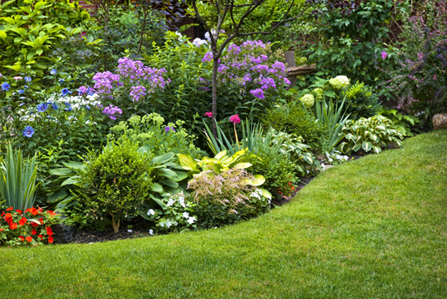

***Return to Table of Contents***

###### 

# **COMMUNITY CALENDAR**

Classes, Community Events and CEU courses

<http://www.seminolecountyfl.gov/departments-services/leisure-services/extension-services/>

|  |
| --- |
| COMMERCIAL |
| The Seminole County Commercial Horticulture Agriculture program provides education and training based on the latest research from the University of Florida.  CEU classes  <http://www.seminolecountyfl.gov/departments-services/leisure-services/extension-services/commercial-resources/>  <http://sfyl.ifas.ufl.edu/education/index.shtml> |
| Training & CEUsMany training programs, certification opportunities, and continuing education units (CEUs) are available through Extension, often in conjunction with FDACS and the USDA. Get information about the courses and materials offered for professionals in Florida's agriculture, building construction, childcare, nutrition, horticulture, and pest control industries.Agricultural ProductionBuilding Construction & DevelopmentChild CareFood & NutritionHorticultural ProductionPest Control & Pesticide LicensingShort CoursesMore online interactive training modules and videos are available (for free or for sale) through Extension Continuing Education Solutions.For information about training programs available for gardeners, naturalists, and beekeepers, see Nonprofessional Programs. <http://solutionsforyourlife.ufl.edu/education/nonprofessional.shtml>For personal assistance or information about the Extension services and courses offered in your area, contact your county Extension office. 407-665-5550  * For information on college-credit courses, certificates and degrees at either the undergraduate or graduate level offered by University of Florida see Distance Learning: <http://www.distance.ufl.edu/> |

# 

***Return to Table of Contents***



# **Should-da – Could-da - Would-da**

## **Hurricane Prep**

*****Hindsight*** *is a dangerous game. Your family and community are important commodities so handle them with care and consideration.*  ***Share*** *this list with your neighbors and/or your HOA to protect your home from flying objects from other sources.*

Palms do not need hurricane pruning. Palms are adapted to wind storms. Removing fronds is of no benefit and is detrimental to the palm.

Even dying leaves benefit the health of the palm. Do not remove leaves until they are completely brown. This should be a general rule for palm maintenance: Trim only fonds that are completely brown and remove the flower/fruiting to avoid the mess it creates.

* **Trim**and cut back bushy plants and vines.
* **Spindly evergreens** are especially likely to fall in the event of a hurricane.
* **Cut away** any tree branches that hang over the roof: the winds will whip those branches around against your roof and will cause major damage.
* **Prune Trees** that are one sided or leaning, to balance out their weight. *Soft ground after a hurricane won’t be able to hold an unbalanced tree.*
* **Lay things down**: potted plants; trellises (if possible); bird baths; fountains; garden art; statues; gazing balls; flags.
* **Pull up** stakes, remove from plants and lay the plants down.
* **Move**tools, watering cans, mowers, wheelbarrows, BBQ grills, lawn furniture inside, lay them down, or turn them over.
* **Take down** bird feeders and hanging plants.
* **Secure** sheds with straps or tie downs.
* **Secure and Brace** windows and doors, particularly screen doors on decks and porches.
* **Stake** and *securely* support newly planted trees.
* **Disconnect**, roll up and store hoses, electric cords, clotheslines, and ropes.
* **Remove** and store pet houses and lead lines.
* **Block** possible entrances for wildlife – they will be looking for safety, too.
* **Unblock** rain gutters and downspouts.
* **Clear** walkways.
* **Do not sink** any furniture into a swimming pool; this is an old myth and a very bad idea.
* **Call your mother!**

*Return to Table of Contents*